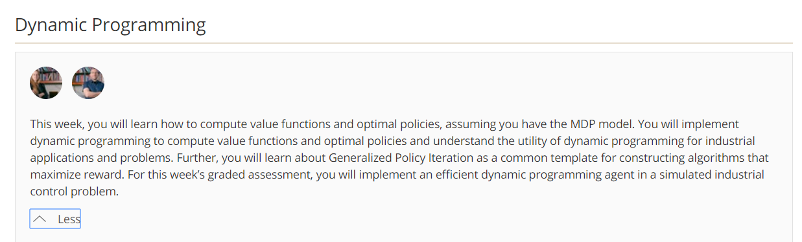

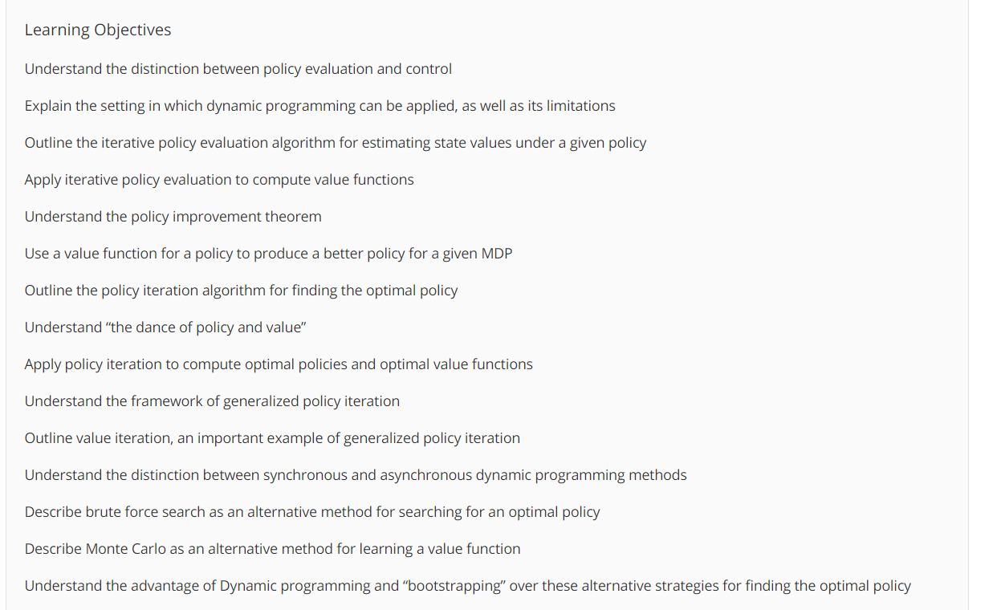

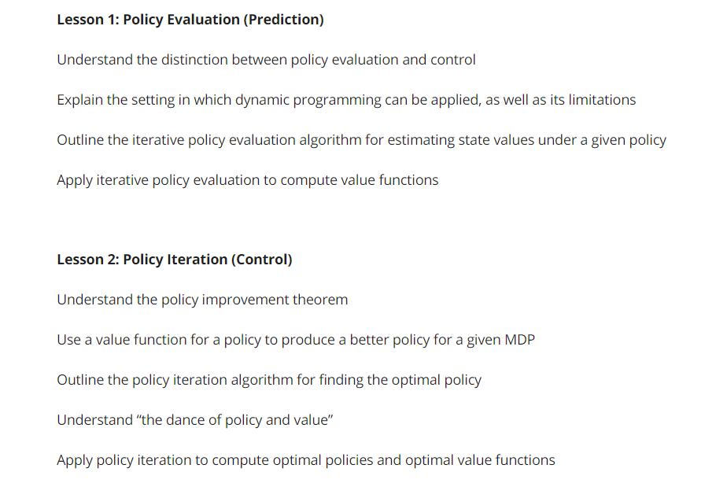 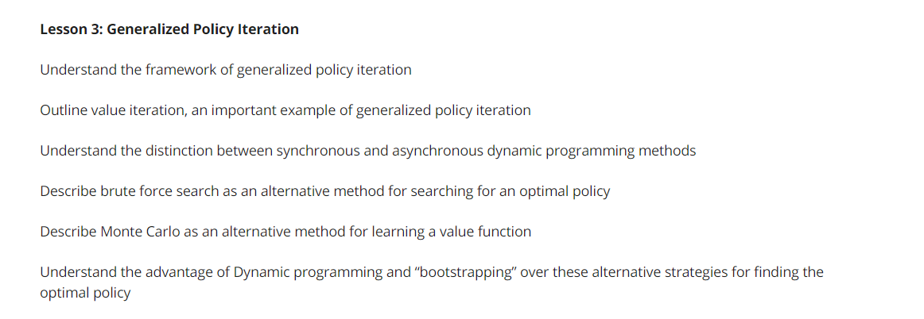

1. **Policy evaluation** = Task of Determinging value function of specific policy(evaluate a policy.hoe good is each policy)
2. **Control** =task of finding a policy to obtain as much as reward as possible.(finding policy that maximizes value function)
3. Control is ultimate goal of RL
4. 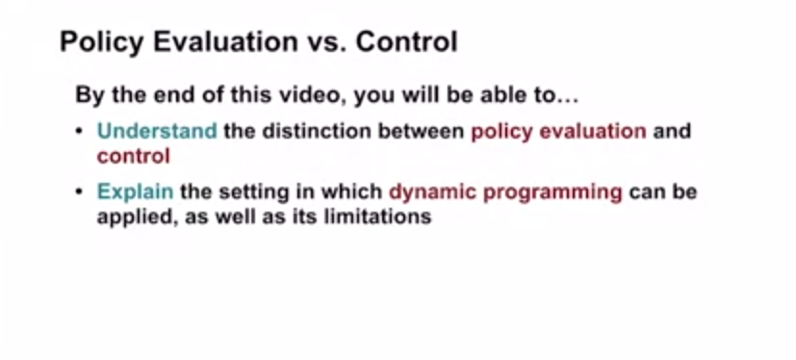
5. .
6. 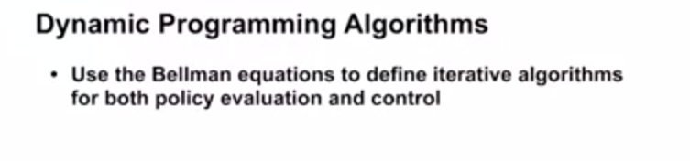
7. .
8. 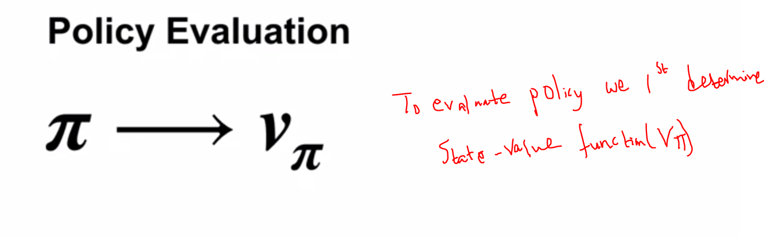
9. . 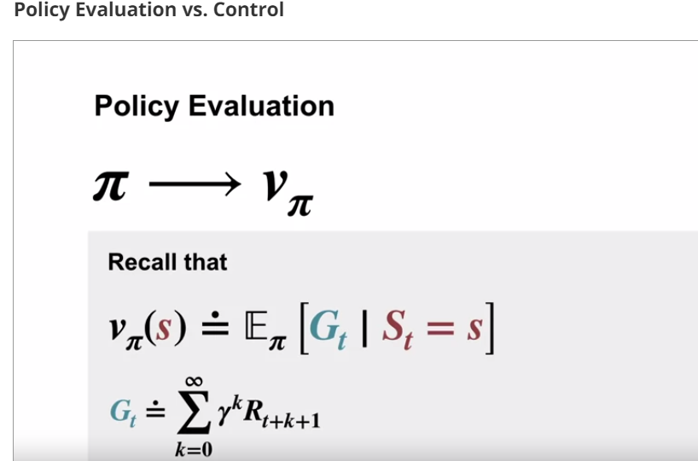
10. .
11. As we have seen Bellman equation which reduces the problems of finding Vpi to a system of linear equations . One equation for each state
12. .
13. 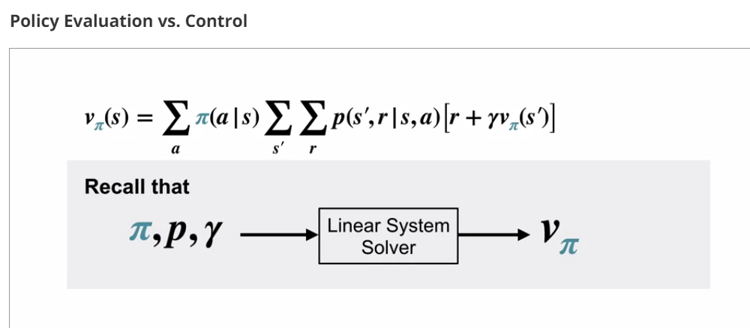
14. .
15. 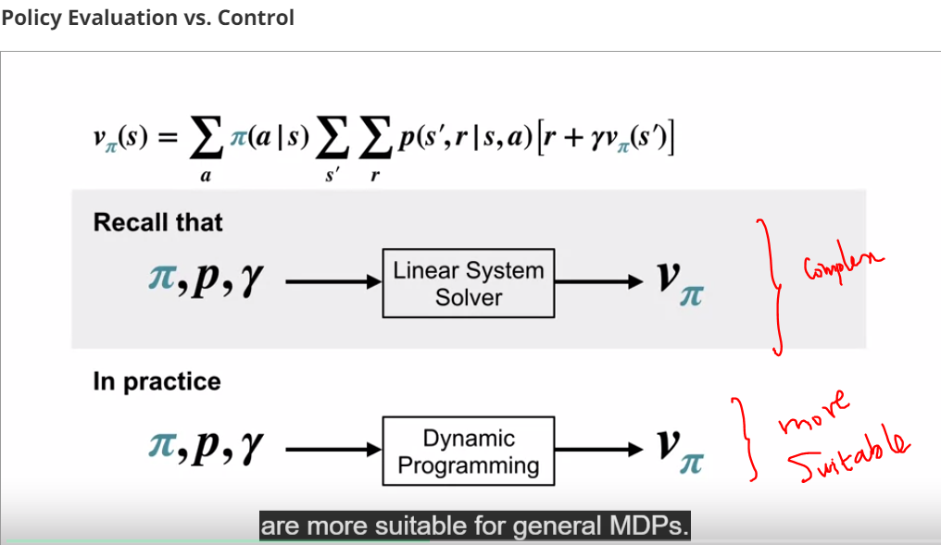
16. .
17. 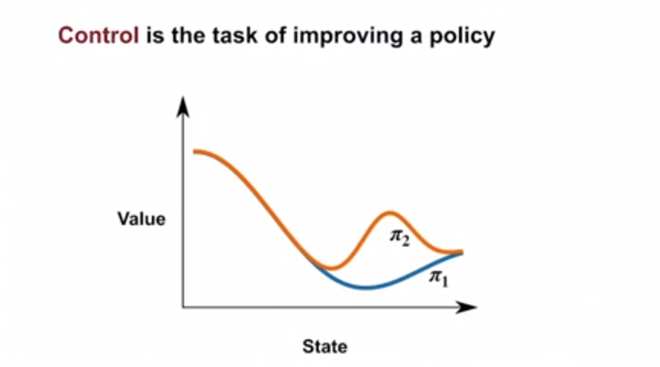
18. .
19. 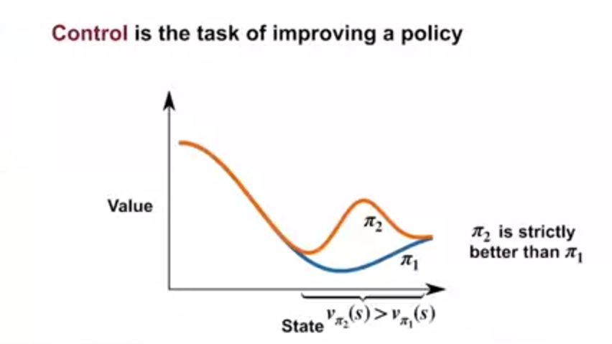
20. .
21. 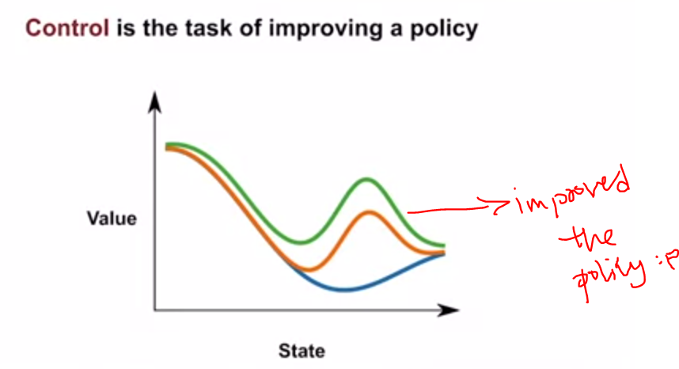
22. . 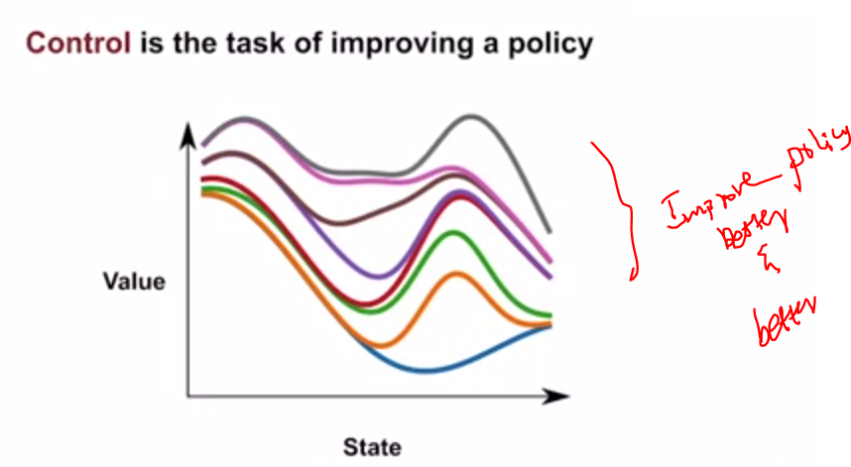
23. .
24. 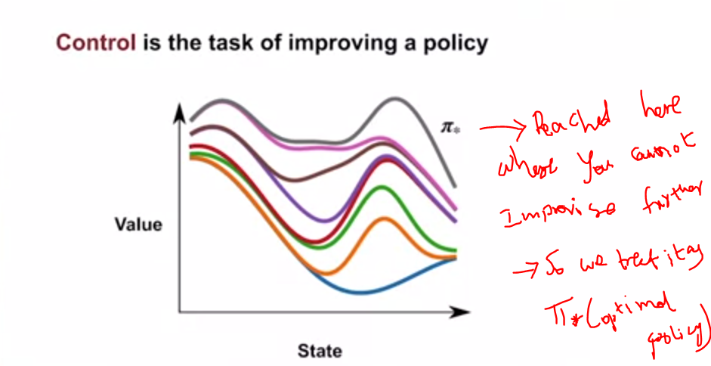
25. .
26. 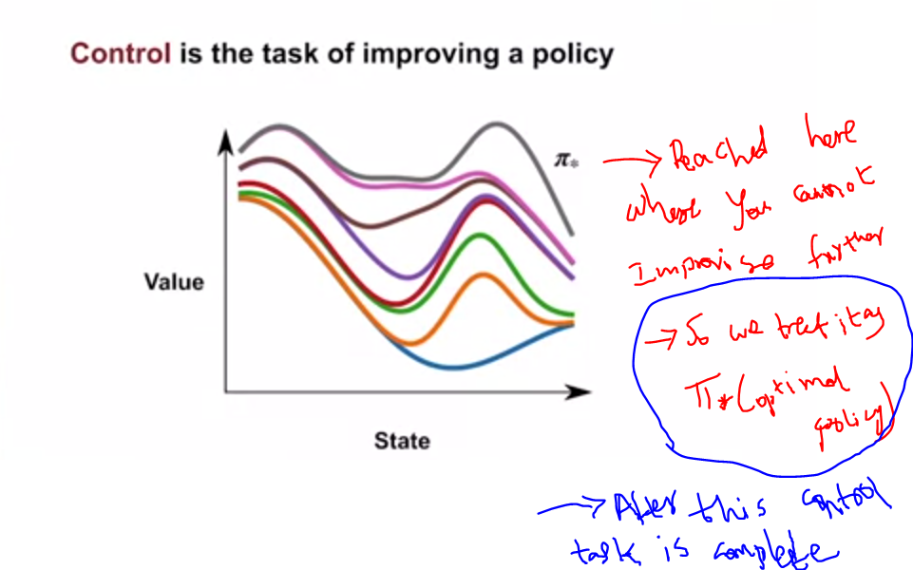
27. .
28. 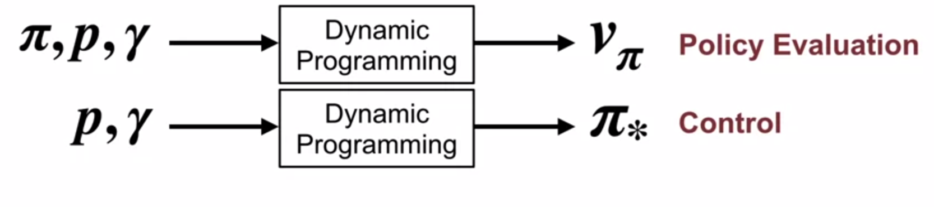
29. .
30. P here is **Dynamics** of Environment .(transition probabilities)
31. .
32. Dynamic programming uses various bellman equations and Knowledge of P to solve optimal policies and value functions
33. .
34. **Big picture**: Most reinforcement learning algorithms seen as **approximation to dynamic programming without the model**
35. **.**
36. 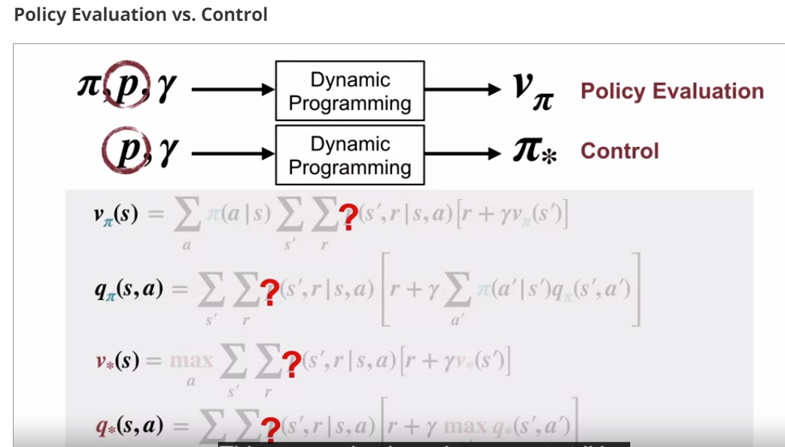
37. 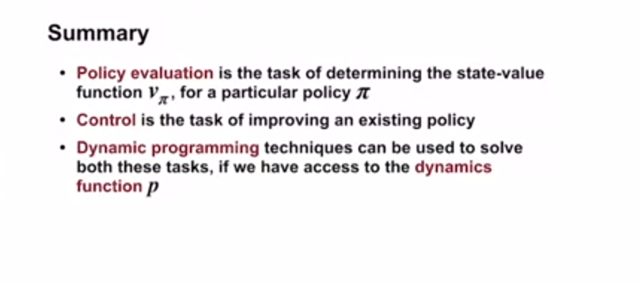
38. **..** 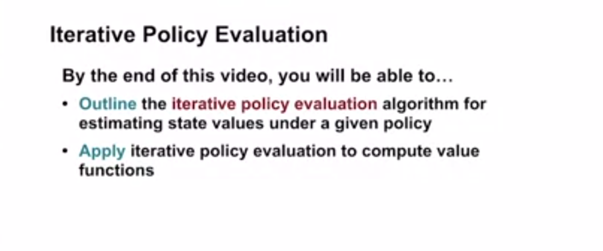
39. **.**
40. 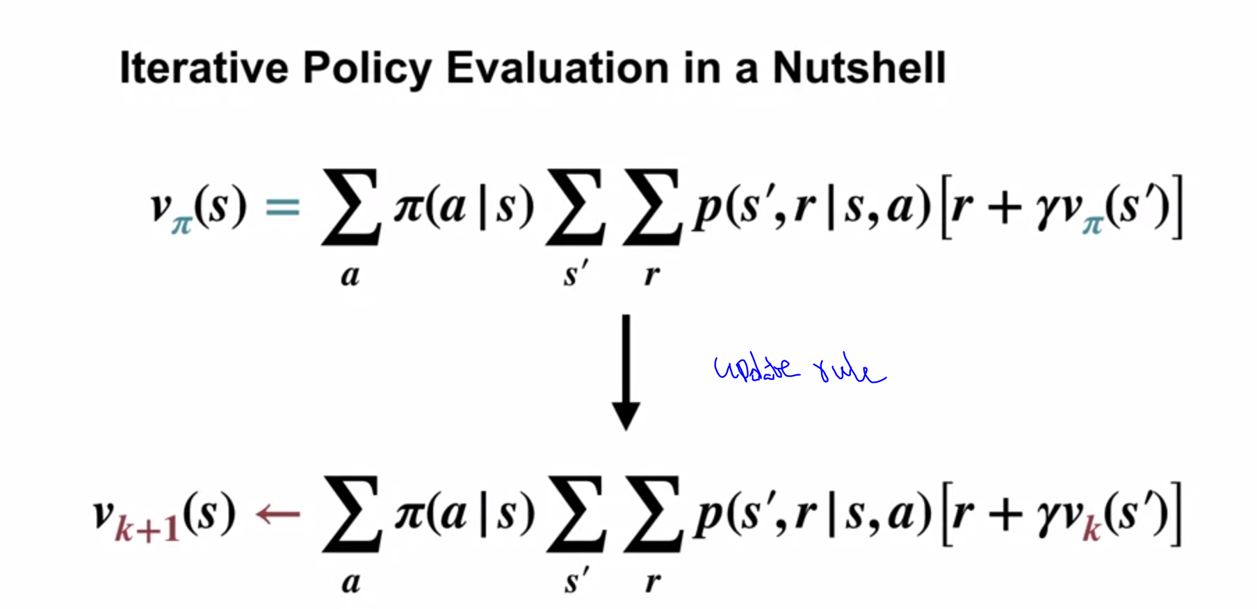
41. **.**
42. **We iteratively refine estimate of value function.this way we better and better the approximation of value function**
43. 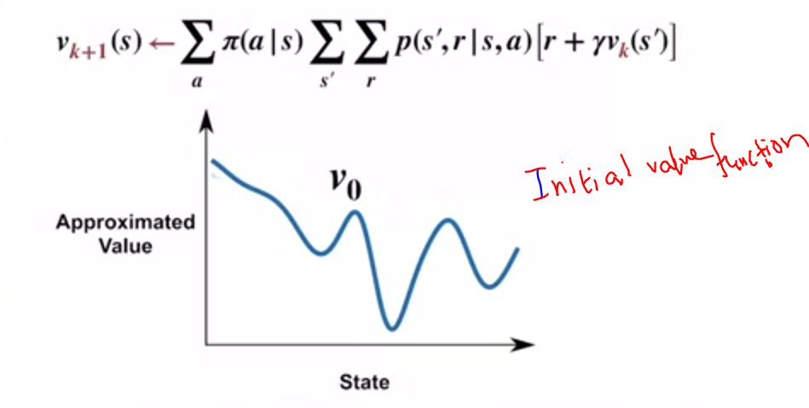
44. **.**
45. 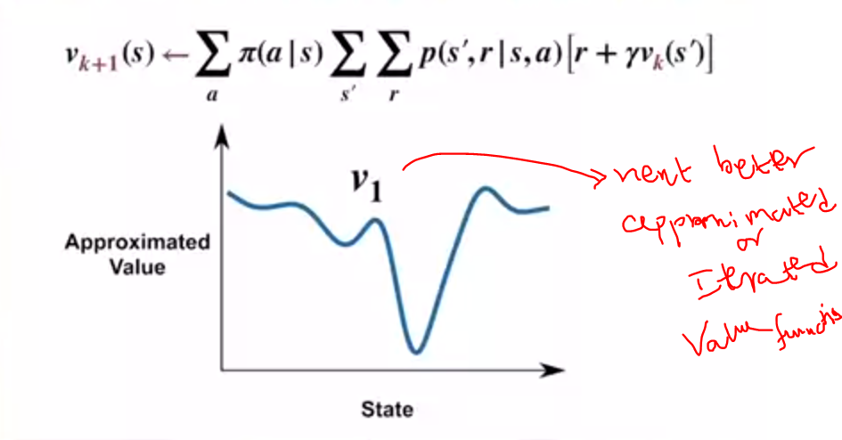
46. **.**
47. **V1 is updated based on Vk+1 update rule**
48. **.**
49. 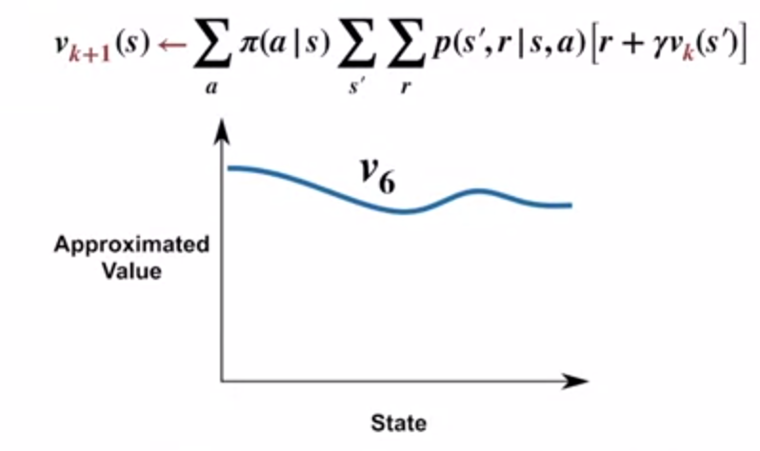
50. **.**
51. **After some itearations we find that Vk+1 will be same as Vk for all states,then we consider it as Vpi**
52. **.**
53. 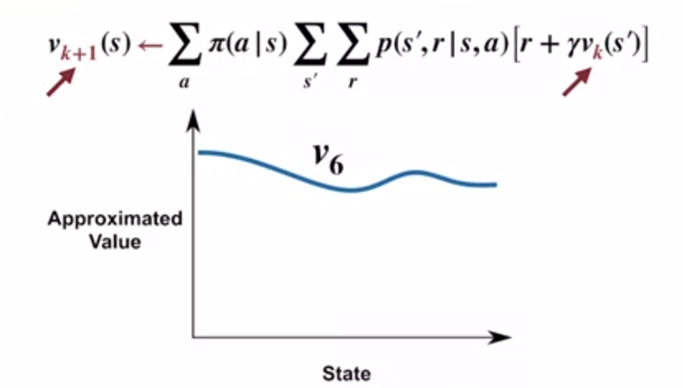
54. **.**
55. 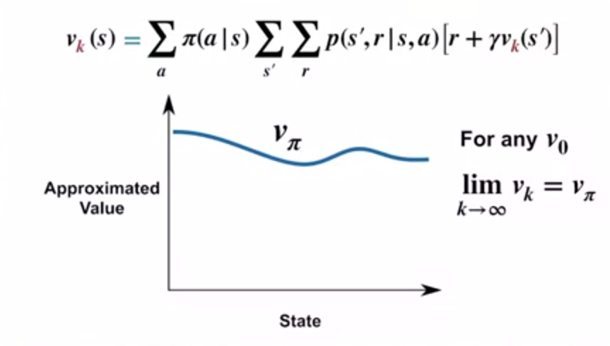
56. **.**
57. 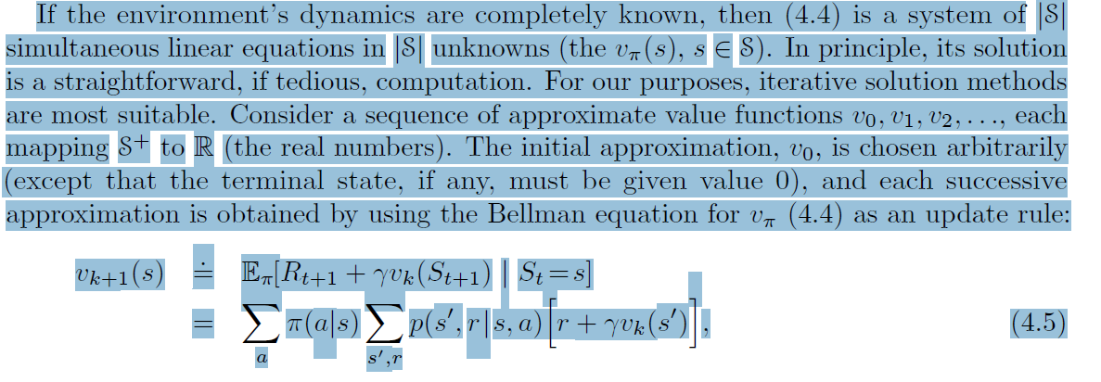
58. **.**
59. **Lets take previous example of grid and do iterative policy update**
60. 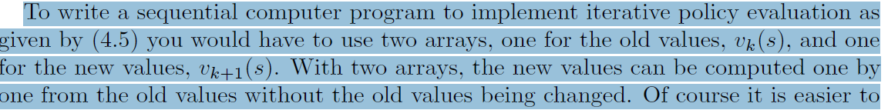
61. **.** 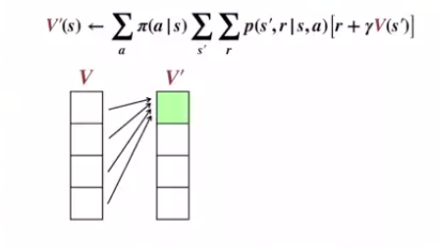
62. **.**
63. 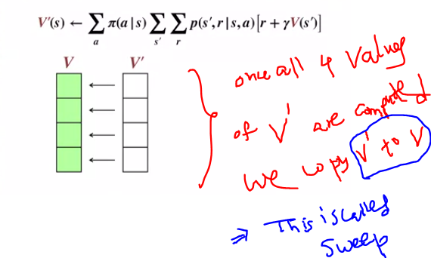
64. **.**
65. 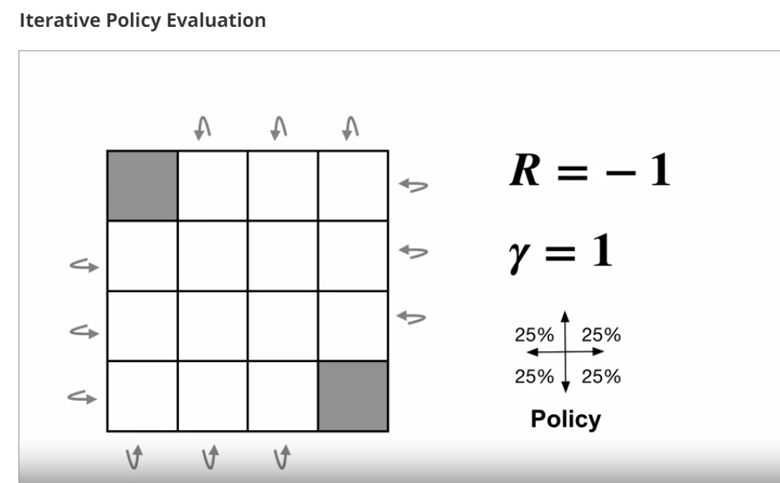
66. **.**
67. 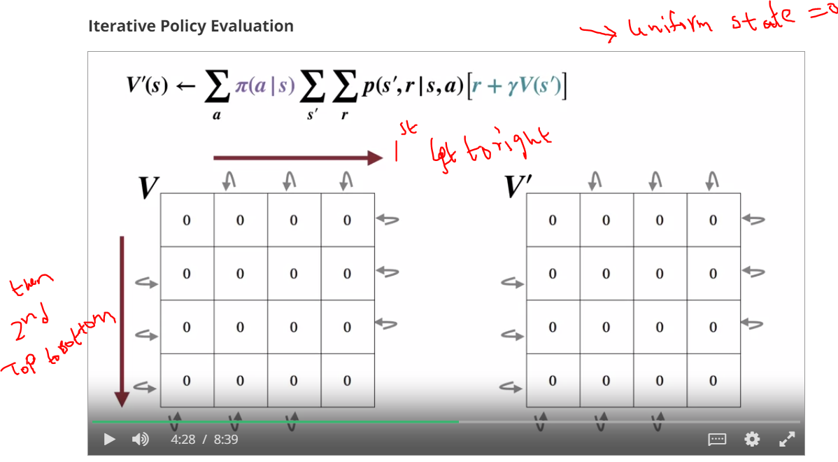
68. **.**
69. **V=old ,V’ =new values.**
70. **We update only new values based on old values**
71. **.**
72. 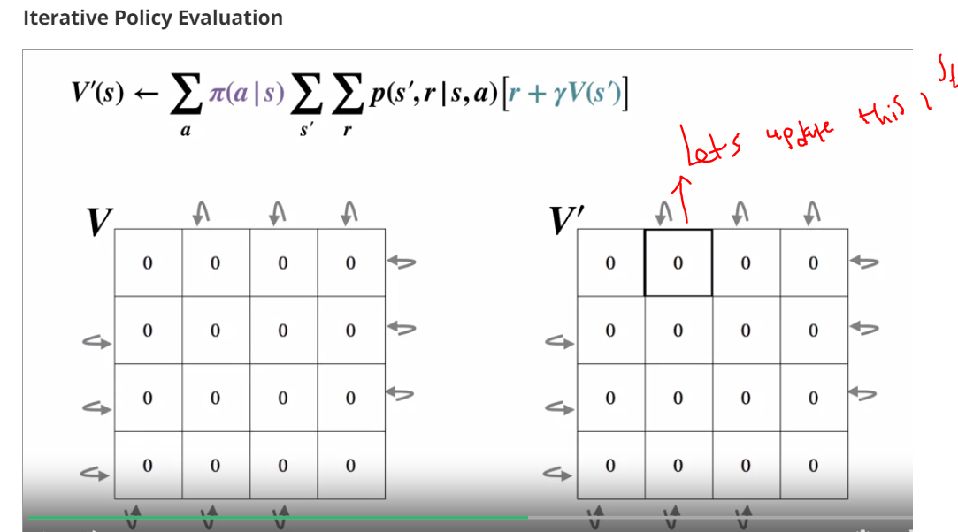
73. **.**
74. **PI(a,s) =probability of choosing 1 action out of 4 actions**
75. **Since we took uniform random policy selection initially ,its ¼ =0.25**
76. **.**
77. 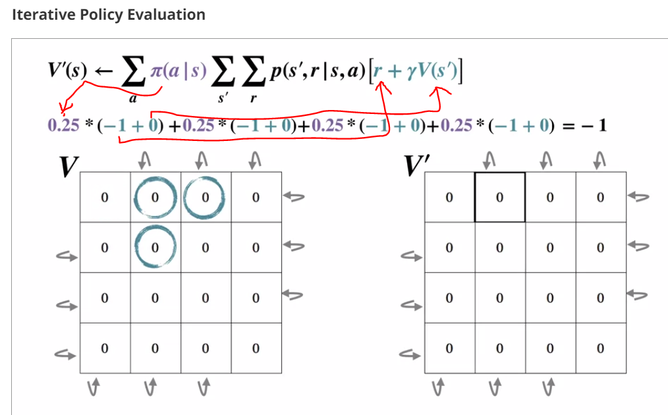
78. **.**
79. 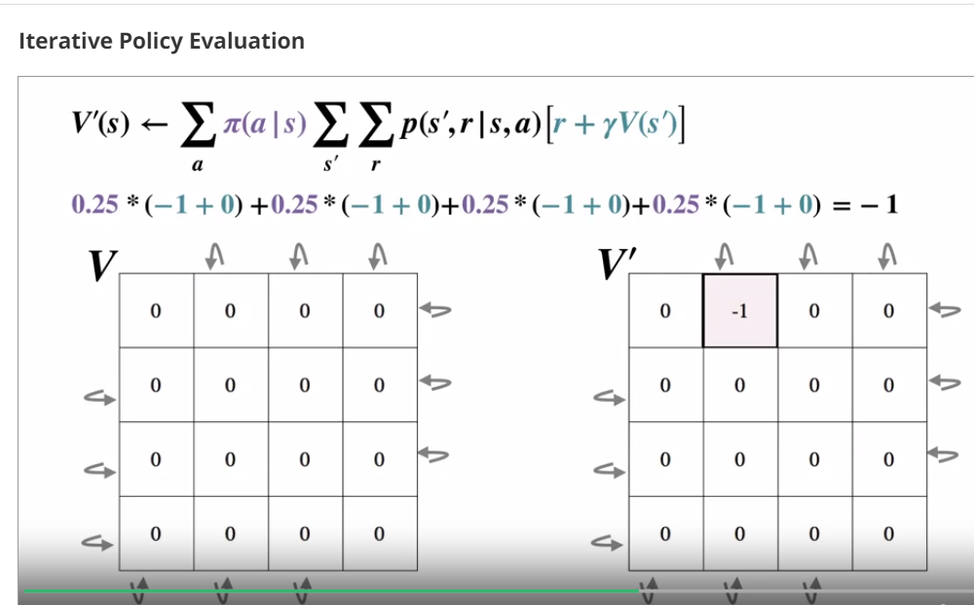
80. **.**
81. 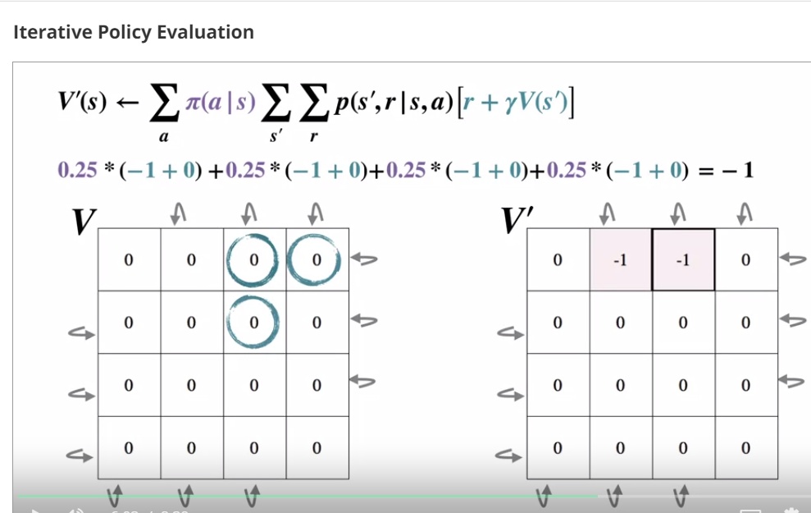
82. **.**
83. 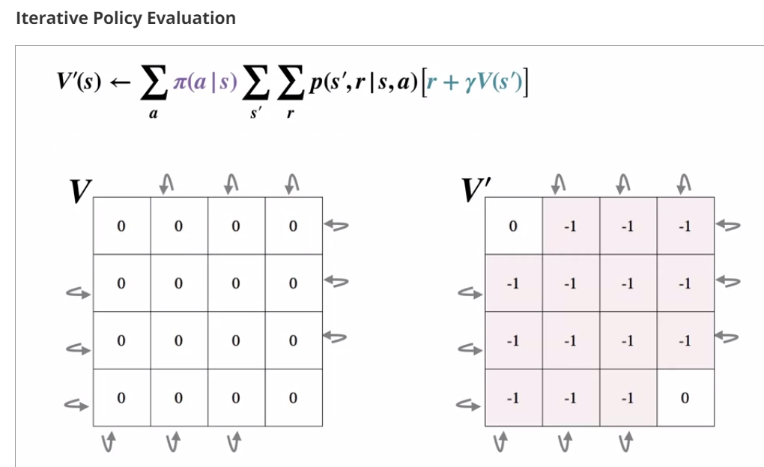
84. **We updated all states of V’**
85. **Now we copy all V’ to V = 1st sweep**
86. **.**
87. 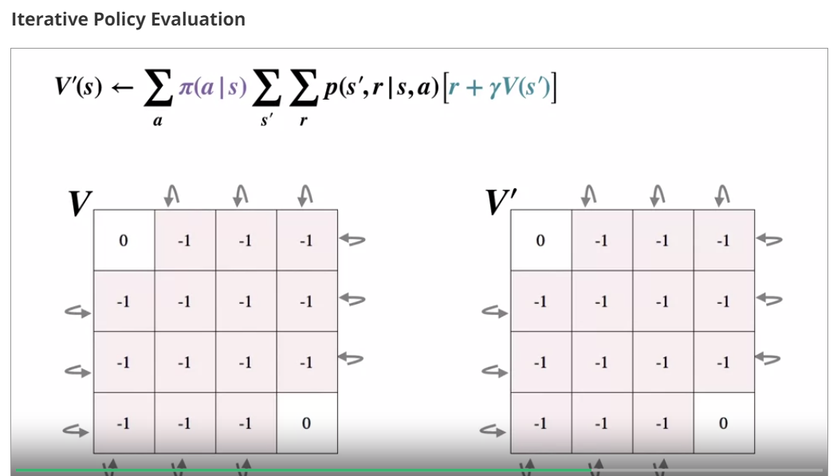
88. **.**
89. 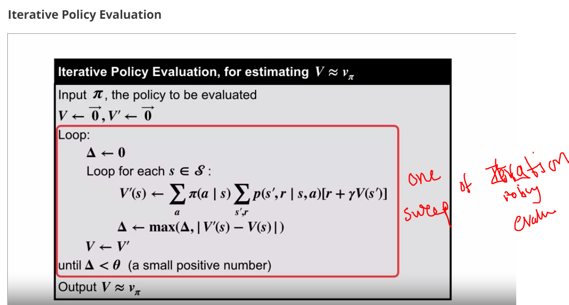
90. **.**
91. 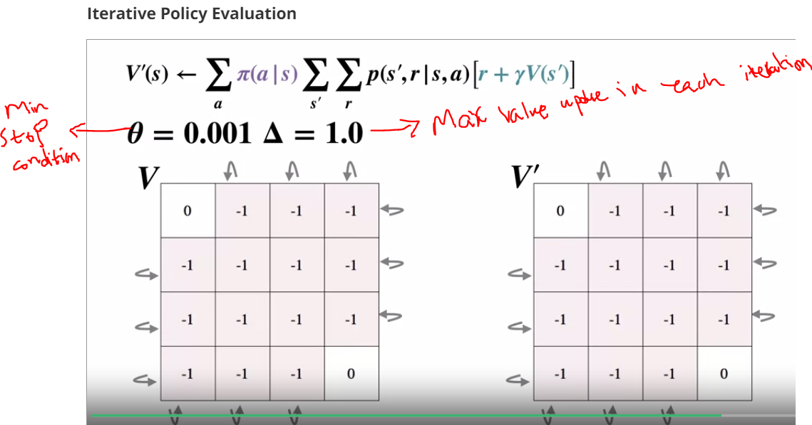
92. **.**
93. **Now lets start 2nd iteration**
94. **.**
95. 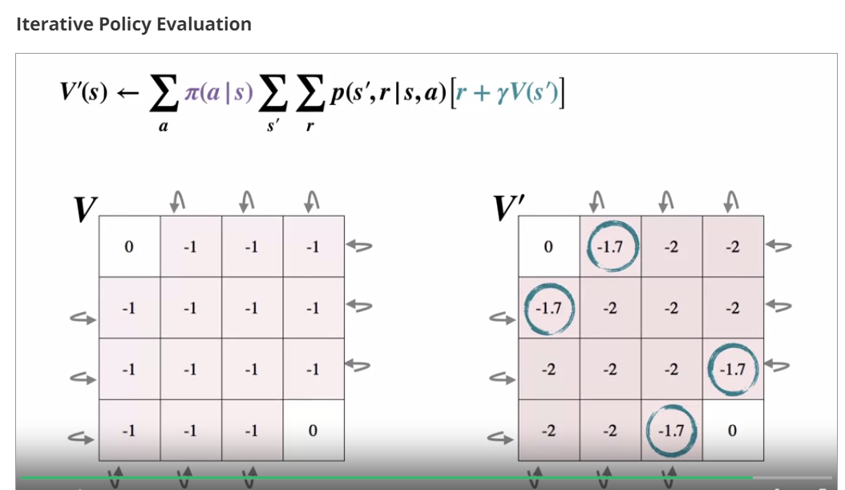
96. **.**
97. **Lets do 2rd iteration**
98. **.**
99. **.**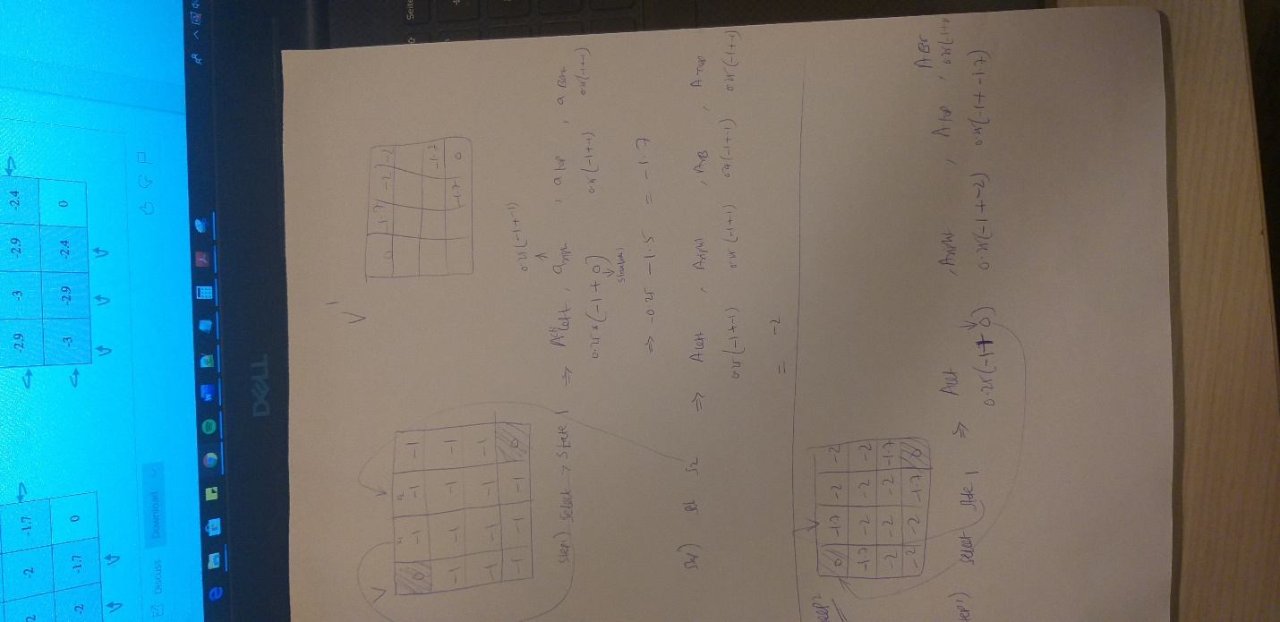
100. **.**
101. 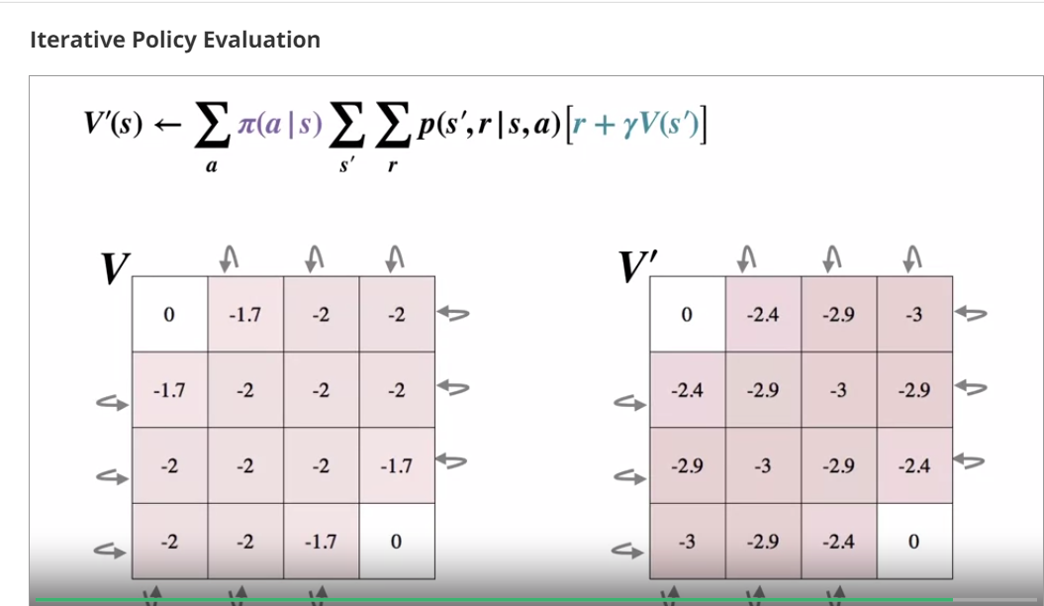
102. **Finally**
103. 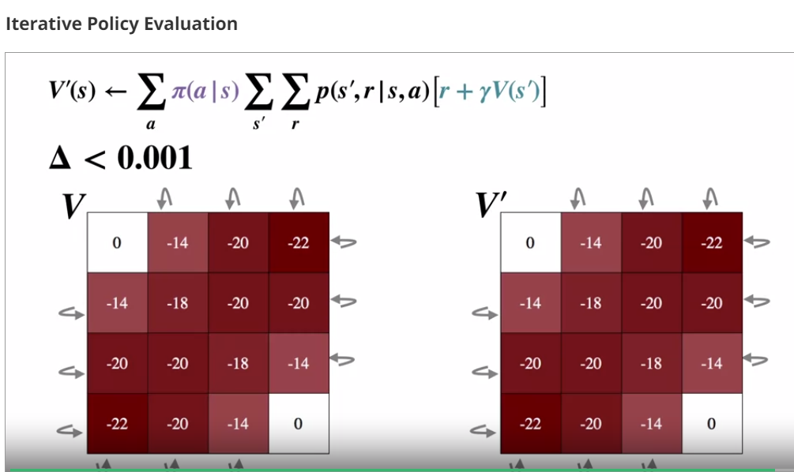
104. **.**
105. 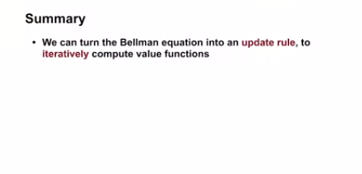
106. 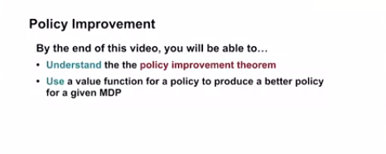
107. **.**
108. 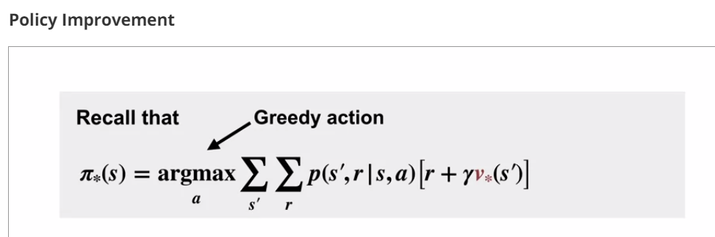
109. **.**
110. 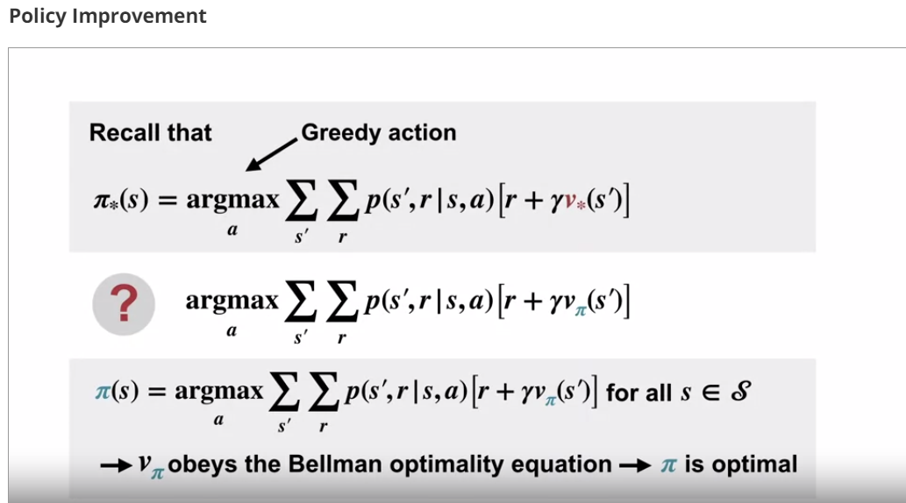
111. **.**

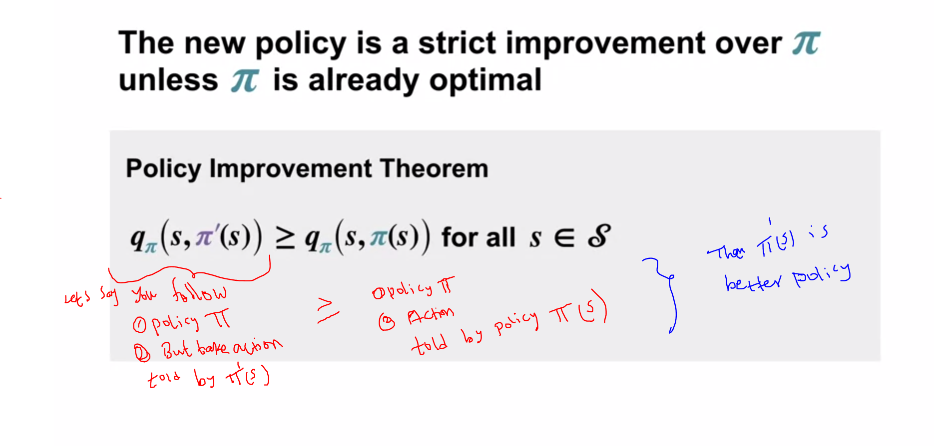

1. 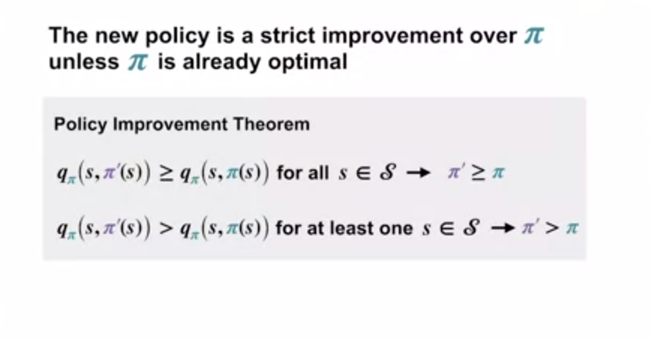
2. 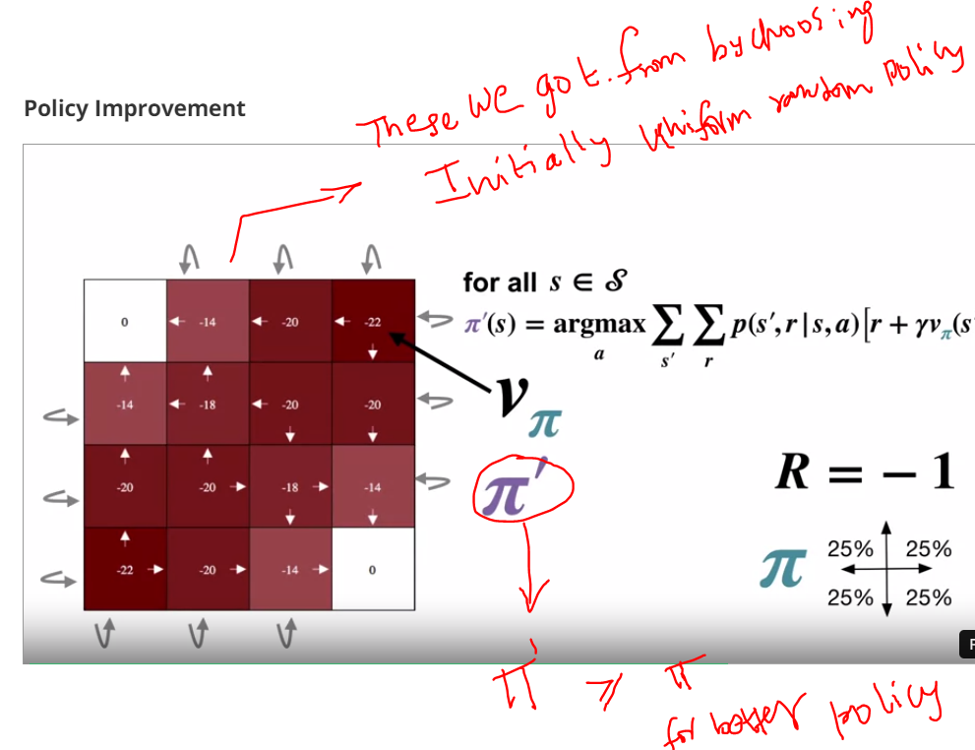
3. .
4. 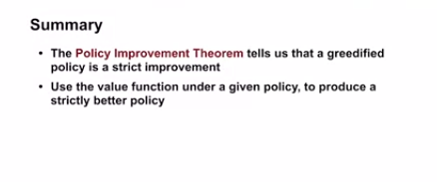
5. .
6. 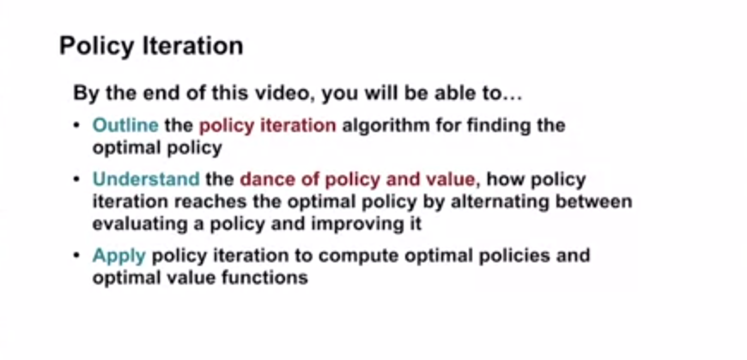
7. .
8. 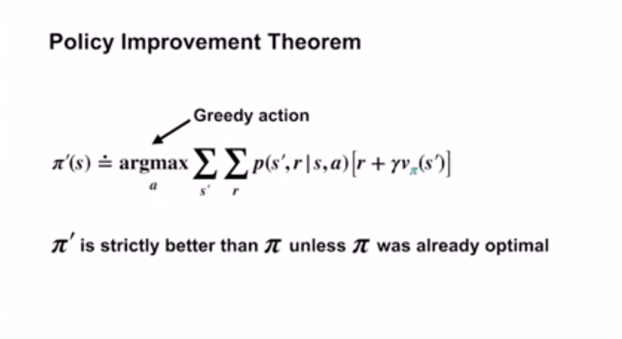
9. 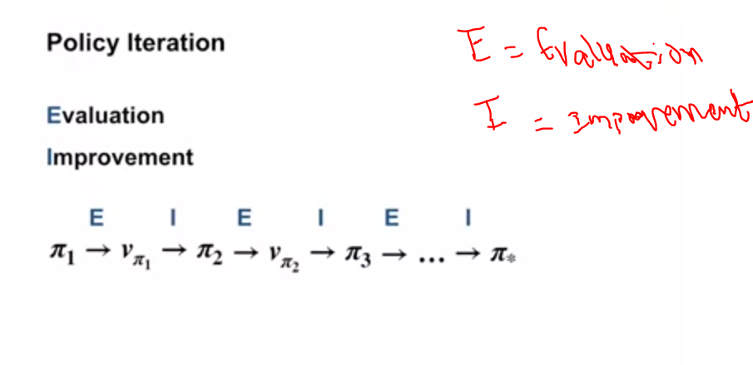
10. .
11. 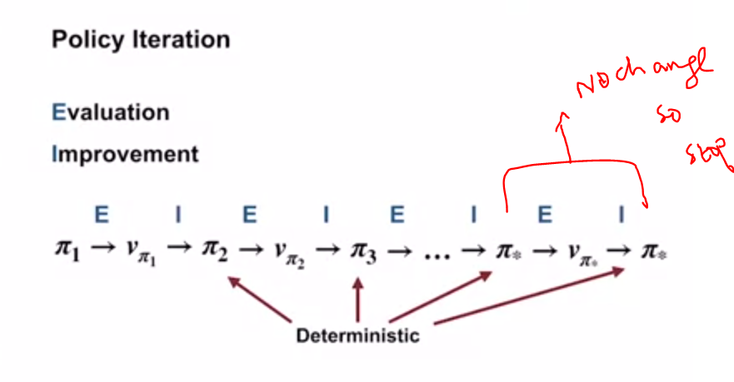
12. .
13. 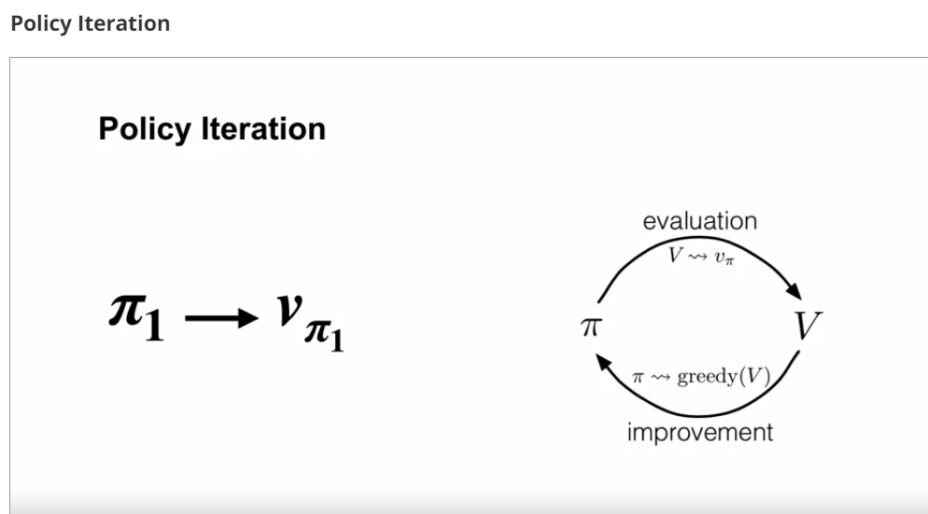
14. .
15. 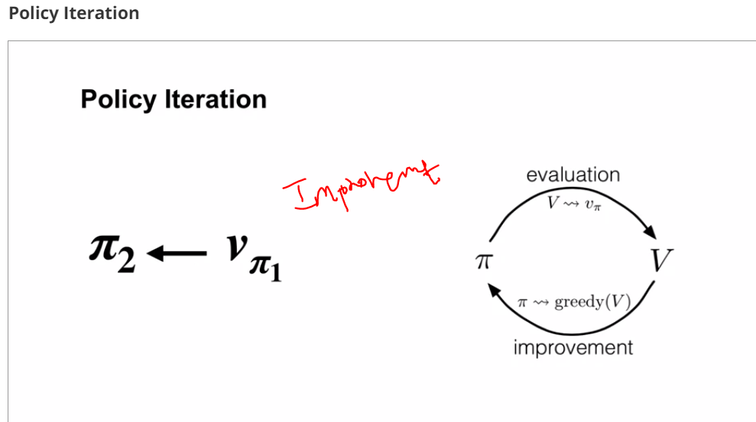
16. .
17. After some iterations like above,we reach dead end
18. 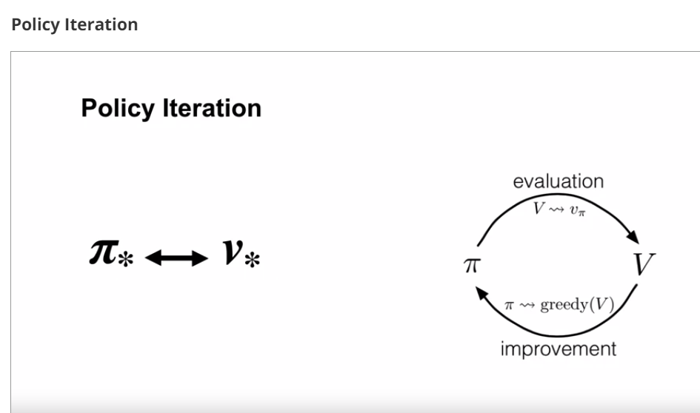
19. .
20. 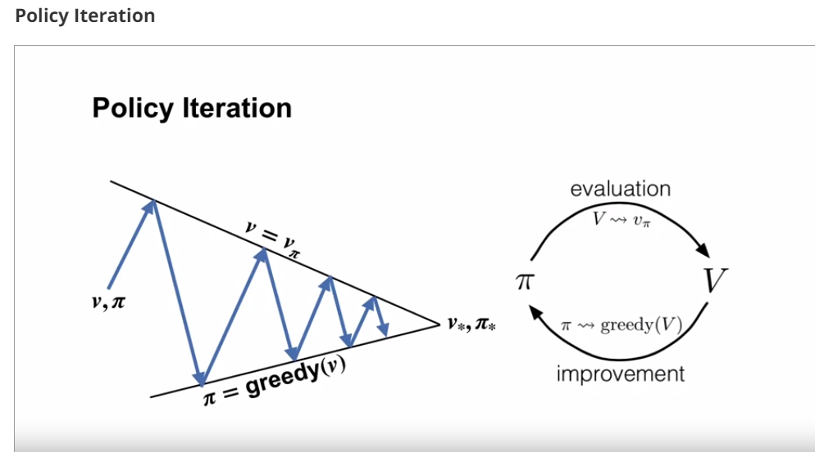
21. .
22. 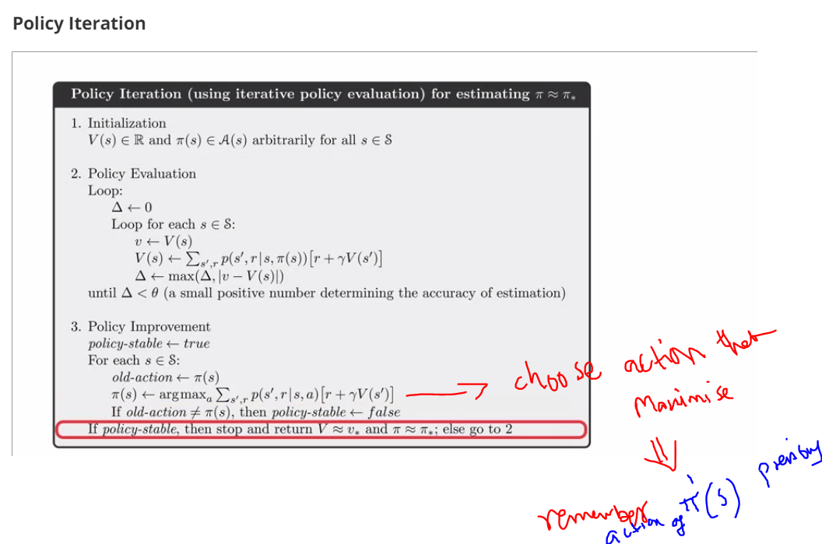
23. .
24. 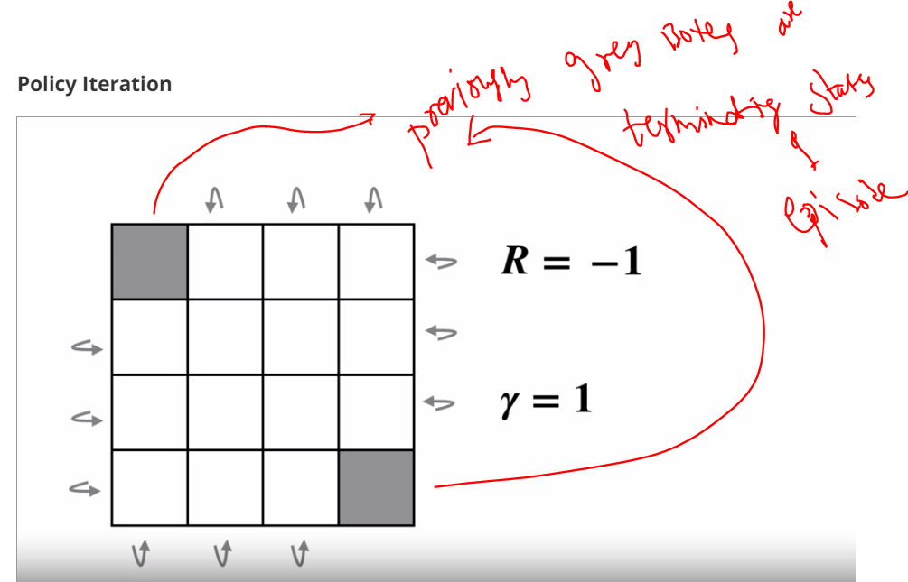.
25. 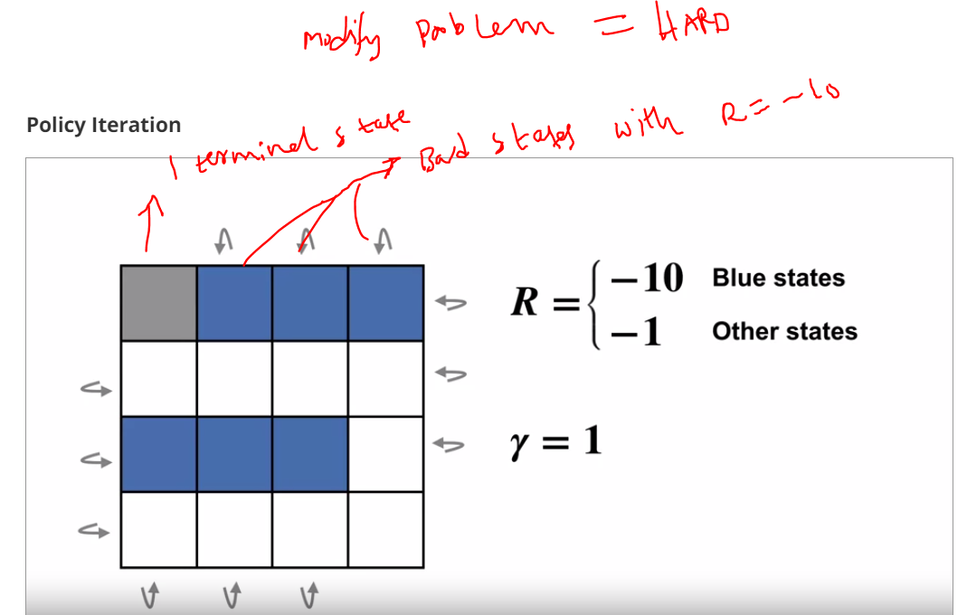
26. .
27. Start the solution for finding optimal policy through policy iteration
28. Lets choose initial random policy and value-function (set value estimates to 0)
29. .
30. 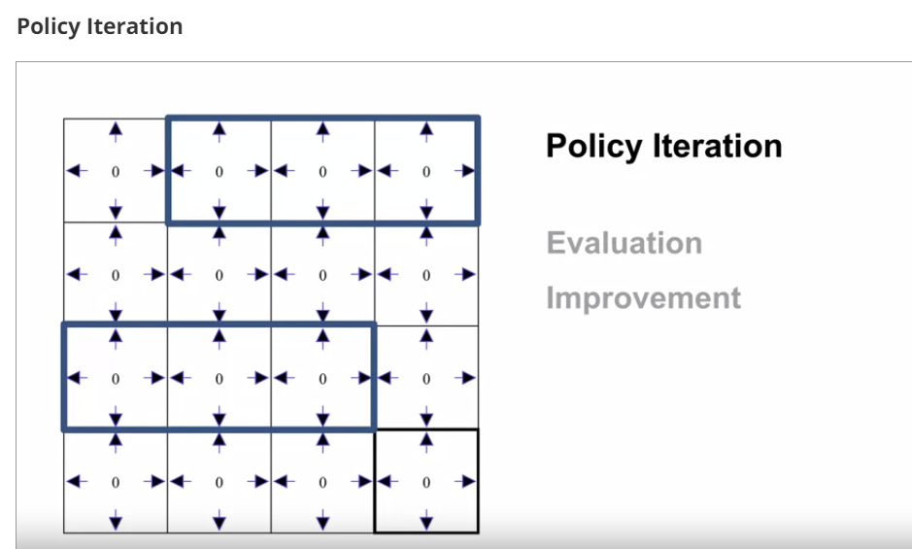
31. .
32. Step1:Lets now use Iteration policy evaluation to evaluate uniform random policy
33. 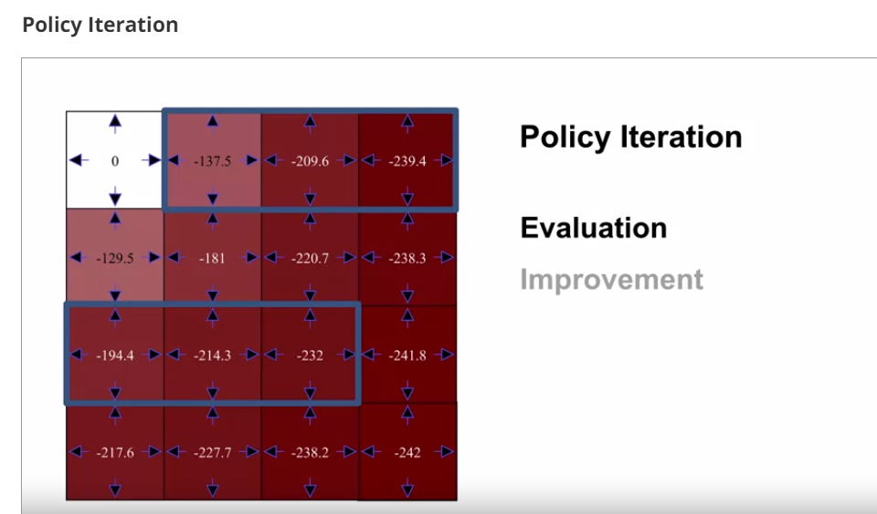
34. .
35. In evaluation,we observe values are getting slightly less at terminal state
36. .
37. Step2:lets do improvement step
38. .
39. 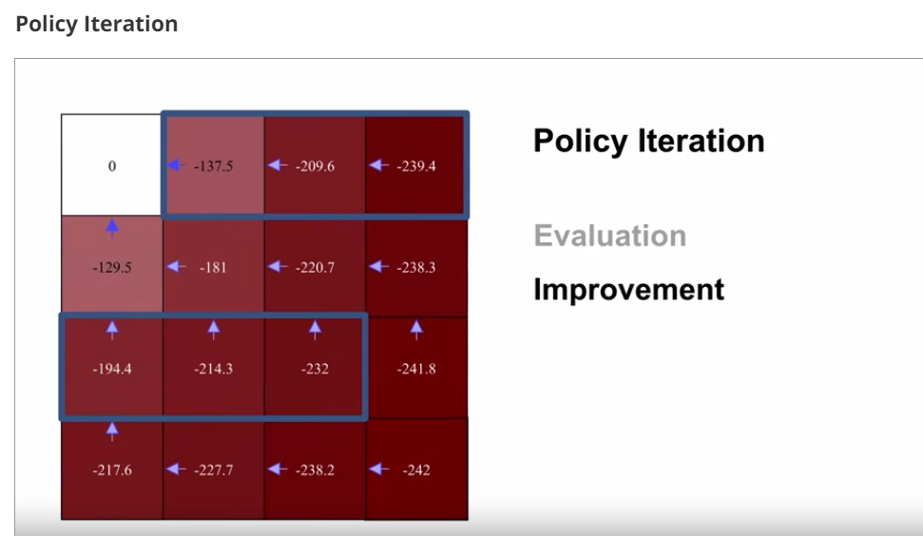
40. .
41. 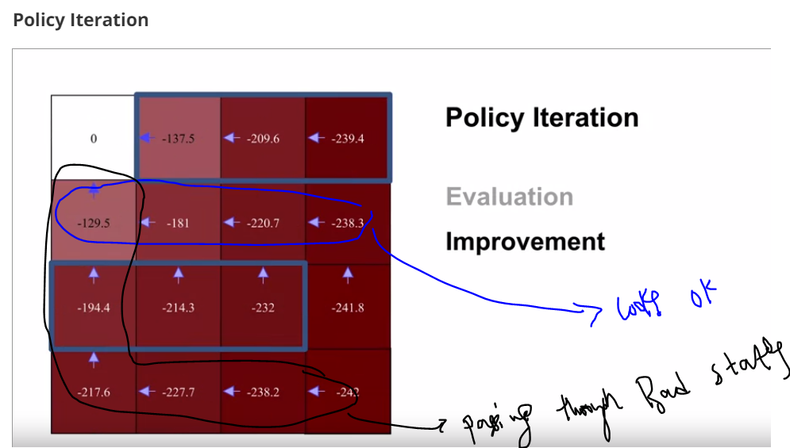
42. .
43. Step4:evaluation
44. .
45. 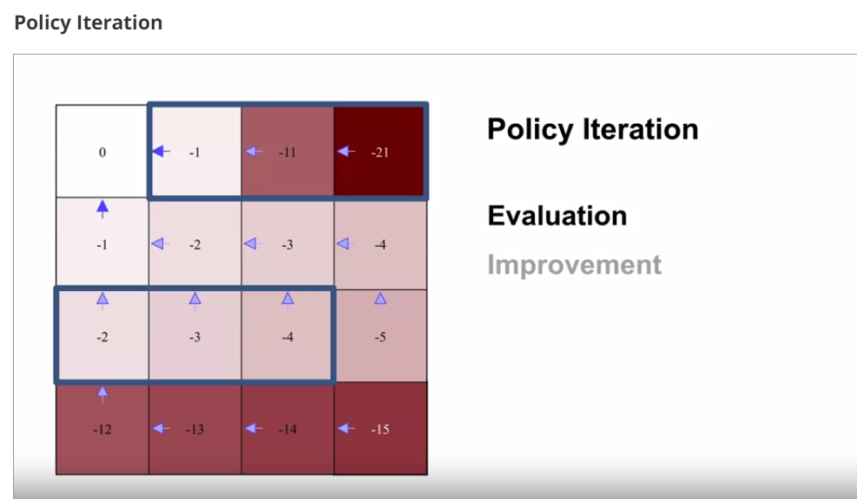
46. .
47. .
48. .
49. .
50. 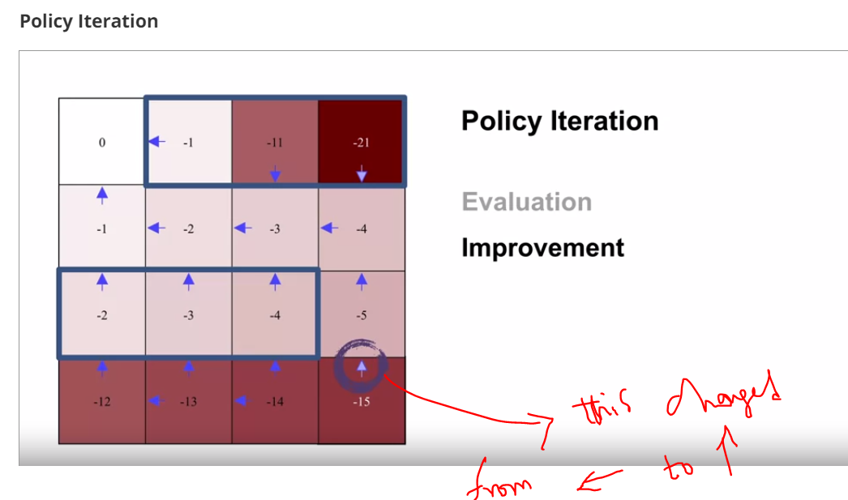
51. .
52. 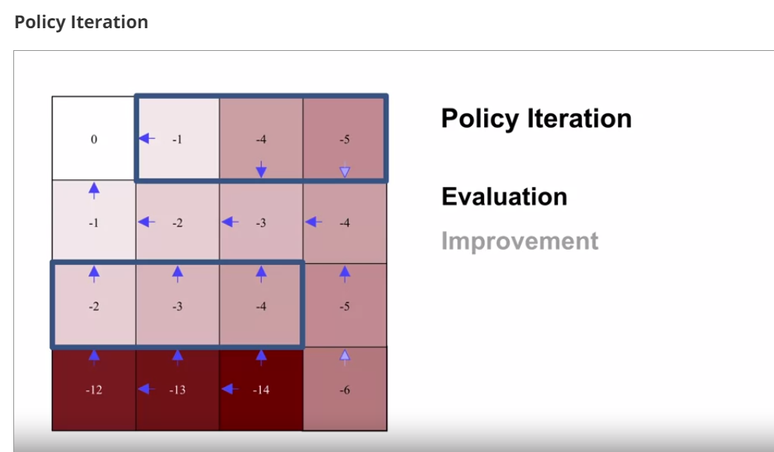
53. .
54. 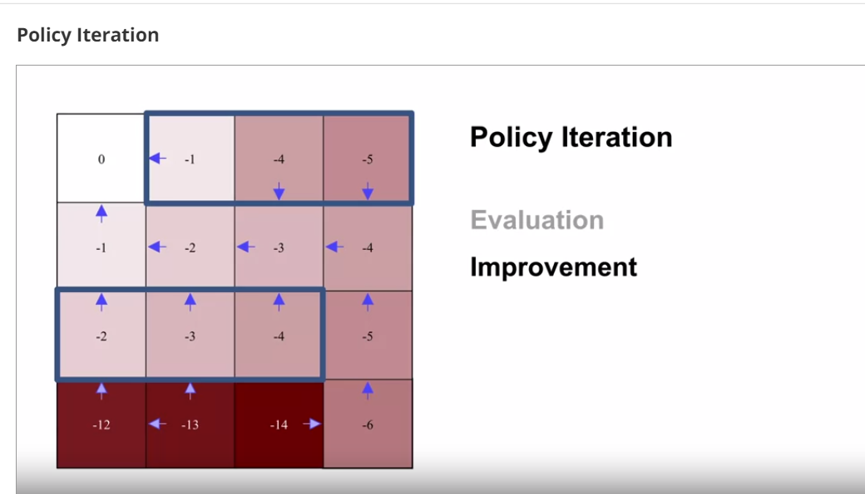
55. .
56. Lets run for some iterations
57. . 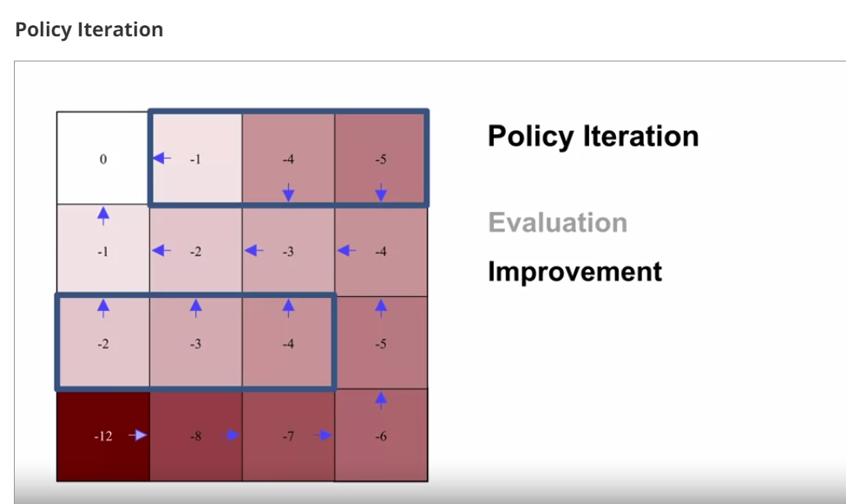
58. .
59. 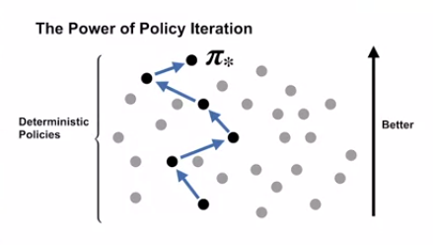
60. .
61. 